Date -

Experiment – 5
Python Programming

Program – 1

AIM :
To create a new program called HelloWorld.py . This file should be used to write your ”Hello World !” program.

PROGRAM :

p1.py

print('Hello World')

OUTPUT:

Hello World

RESULT :
Thus the program is executed and output is obtained.

Program – 2

AIM :
To write a function reverse to reverse a list without using the reverse function.

PROGRAM :

p2.py

li = [1, 2, 3, 4, 5]
print('Original List : ', li)
print('Reversed List : ', li[::-1])

OUTPUT:

('Original List : ', [1, 2, 3, 4, 5])
('Reversed List : ', [5, 4, 3, 2, 1])

RESULT :
Thus the program is executed and output is obtained.

Program – 3

AIM :
To write a method fact that takes a number from the user and prints the factorial.

PROGRAM :

p3.py

def fact(n):
fact = 1
for i in range(1, n+1):
fact = fact*i
return fact

n = int(input('Enter n :'))
print(str(n)+'! is : '+str(fact(n)))

OUTPUT:

Enter n :5
5! is : 120

RESULT :
Thus the program is executed and output is obtained.

Program – 4

AIM :
To write a GUI for the expression calculator using tk.

PROGRAM :

P4.py

from tkinter import *

expression = ""

def press(num):
global expression

expression = expression + str(num)

equation.set(expression)

def equalpress():
try:
global expression

total = str(eval(expression))

equation.set(total)

expression = ""

except:

equation.set(" error ")
expression = ""

def clear():
global expression
expression = ""
equation.set("")

if __name__ == "__main__":
gui = Tk()

gui.configure(background="light blue")

gui.title("Simple Calculator")

gui.geometry("300x125")

equation = StringVar()

expression_field = Entry(gui, textvariable=equation)

expression_field.grid(columnspan=4, ipadx=70)

equation.set('enter your expression')

button1 = Button(gui, text=' 1 ', fg='black', bg='pink',
command=lambda: press(1), height=1, width=7)
button1.grid(row=4, column=0)

button2 = Button(gui, text=' 2 ', fg='black', bg='pink',
command=lambda: press(2), height=1, width=7)
button2.grid(row=4, column=1)

button3 = Button(gui, text=' 3 ', fg='black', bg='pink',
command=lambda: press(3), height=1, width=7)
button3.grid(row=4, column=2)

button4 = Button(gui, text=' 4 ', fg='black', bg='pink',
command=lambda: press(4), height=1, width=7)
button4.grid(row=3, column=0)

button5 = Button(gui, text=' 5 ', fg='black', bg='pink',
command=lambda: press(5), height=1, width=7)
button5.grid(row=3, column=1)

button6 = Button(gui, text=' 6 ', fg='black', bg='pink',
command=lambda: press(6), height=1, width=7)
button6.grid(row=3, column=2)

button7 = Button(gui, text=' 7 ', fg='black', bg='pink',
command=lambda: press(7), height=1, width=7)
button7.grid(row=1, column=0)

button8 = Button(gui, text=' 8 ', fg='black', bg='pink',
command=lambda: press(8), height=1, width=7)
button8.grid(row=1, column=1)

button9 = Button(gui, text=' 9 ', fg='black', bg='pink',
command=lambda: press(9), height=1, width=7)
button9.grid(row=1, column=2)

button0 = Button(gui, text=' 0 ', fg='black', bg='pink',
command=lambda: press(0), height=1, width=7)
button0.grid(row=5, column=0)

plus = Button(gui, text=' + ', fg='black', bg='pink',
command=lambda: press("+"), height=1, width=7)
plus.grid(row=1, column=3)

multiply = Button(gui, text=' * ', fg='black', bg='pink',
command=lambda: press("*"), height=1, width=7)
multiply.grid(row=4, column=3)

divide = Button(gui, text=' / ', fg='black', bg='pink',
command=lambda: press("/"), height=1, width=7)
divide.grid(row=5, column=3)

equal = Button(gui, text=' = ', fg='black', bg='pink',
command=equalpress, height=1, width=7)
equal.grid(row=5, column=2)

clear = Button(gui, text='Clear', fg='black', bg='pink',
command=clear, height=1, width=7)
clear.grid(row=5, column='1')

gui.mainloop()

OUTPUT:
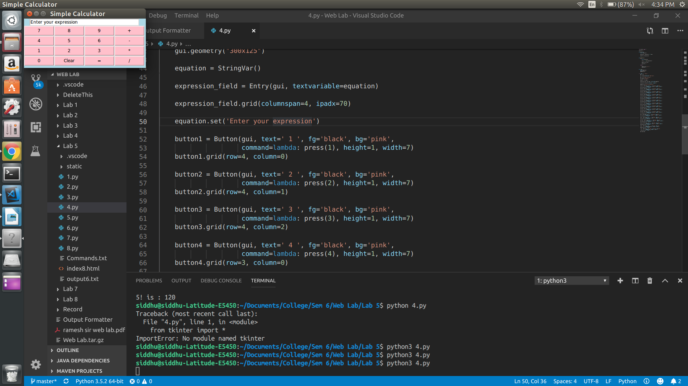
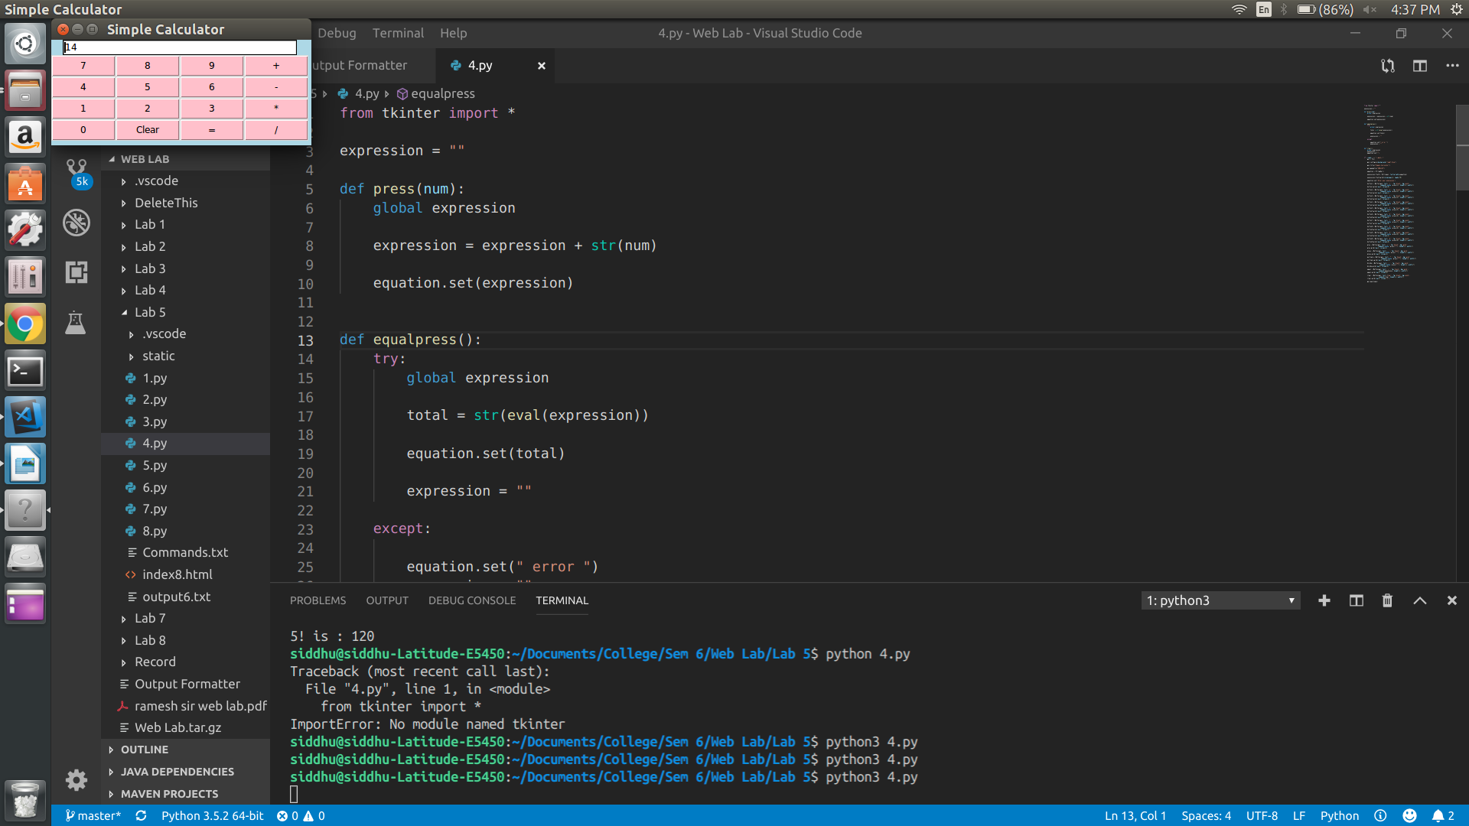
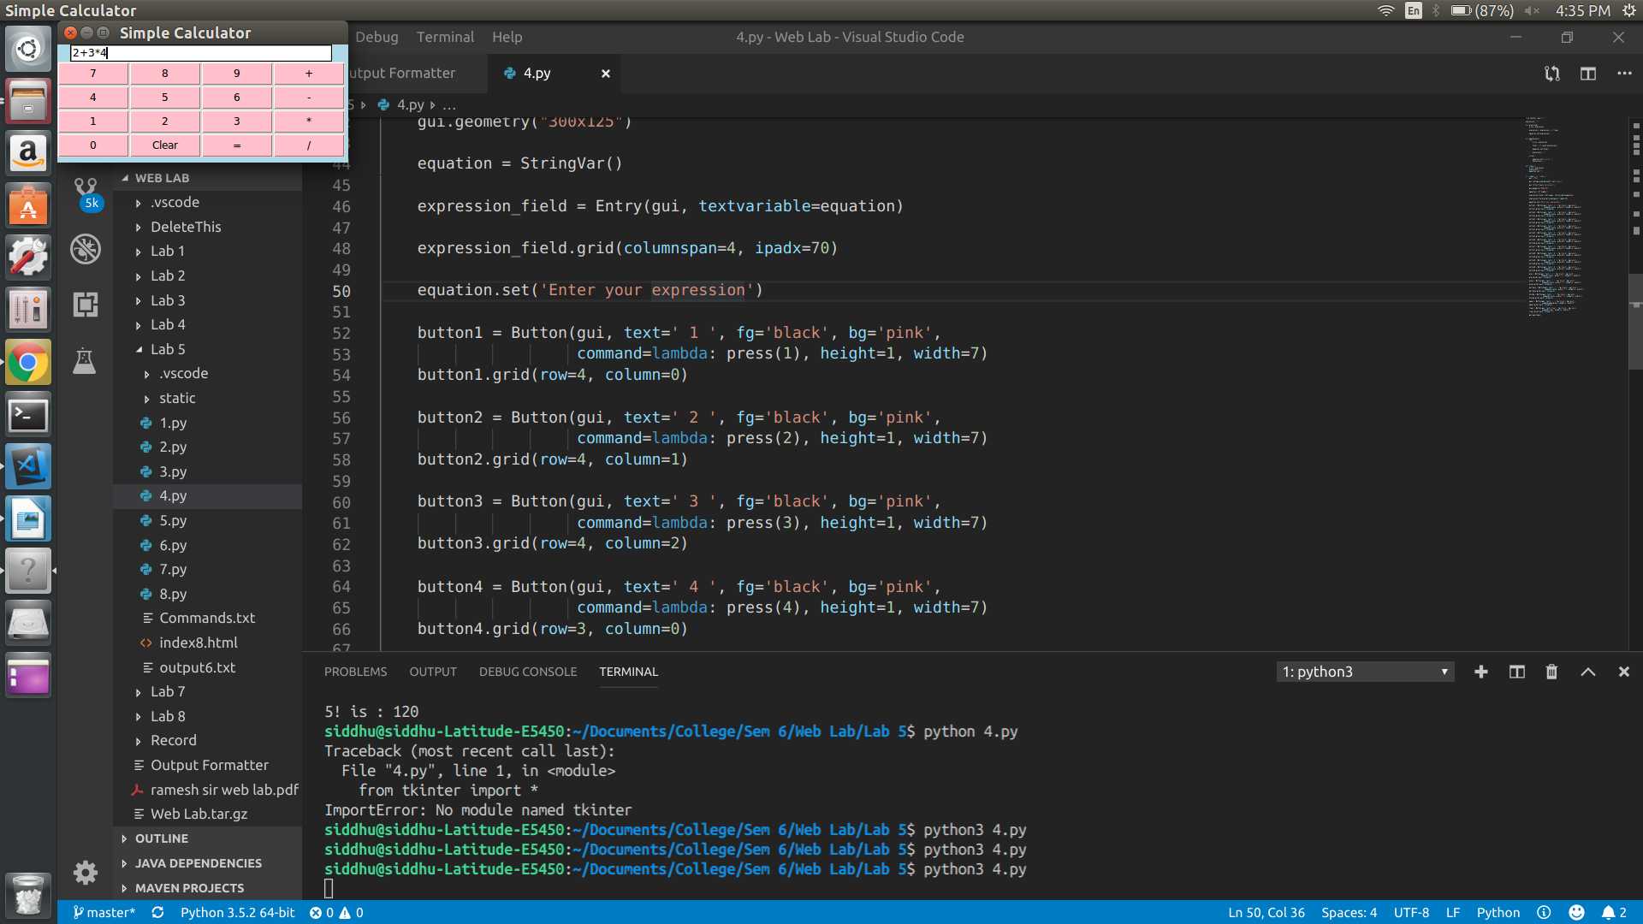
RESULT :
Thus the program is executed and output is obtained.
Program – 5

AIM :
To write a procesure to install packages requests, flask and expore them using pip.
PROGRAM :

P5.py

from flask import Flask
app = Flask(__name__)

@app.route('/')
def hello():
return "Hello World!"

if __name__ == '__main__':
app.run()

OUTPUT:

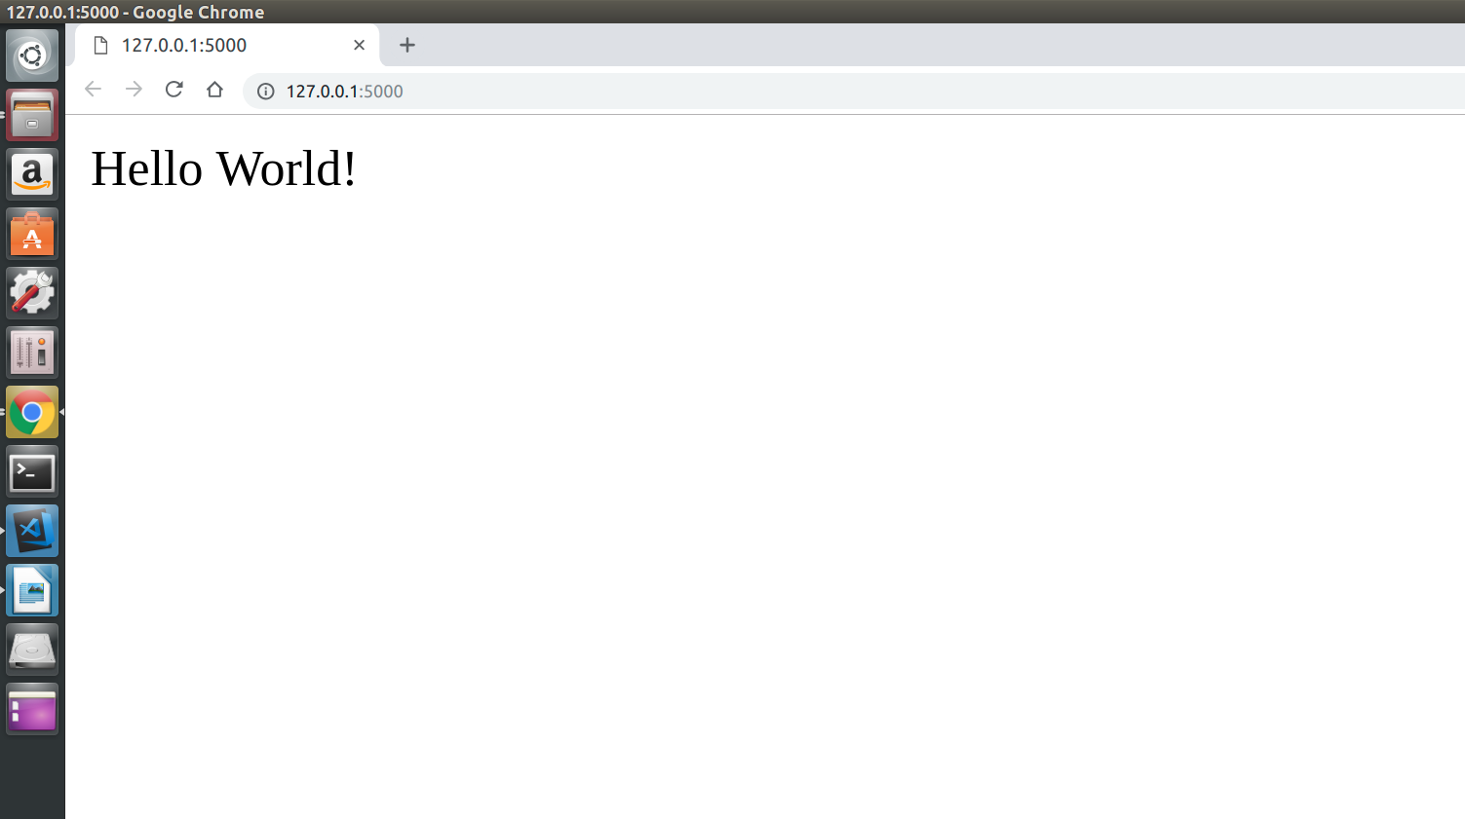

RESULT :
Thus the program is executed and output is obtained.

Program – 6

AIM :
To write a script that imports Requests and fetches the content from a page.

PROGRAM :

p6.py

import requests
from bs4 import BeautifulSoup

try:
out = open('output6.txt', 'w')
page = requests.get('https://www.nytimes.com/')
soup = BeautifulSoup(page.text, 'html.parser')

headlineItems = soup.find_all('title')
for item in headlineItems:
print(item.string)
out.write(item.string+'\n')

print()
out.write('\n')

headlineItems = soup.find_all('article')
for item in headlineItems:
print(item.h2.string)
out.write(item.h2.string + '\n')

except ValueError:
print('Value Error')
except IOError:
print('IOError')

OUTPUT:

Breaking News, World News & Multimedia - The New York Times

Listen to ‘Still Processing’
In ‘The Daily’ Newsletter
Listen to ‘The Argument’
The Enigmatic Figure at the Heart of Mueller’s Inquiry
Manafort ‘Repeatedly and Brazenly’ Broke Law, Prosecutors Say in Sentencing Memo
Some Aid From Brazil Pierces Venezuela’s Blockade
Inside the Rise and Fall of a Multimillion-Dollar Airbnb Scheme
Health Care and Insurance Industries Mobilize to Kill ‘Medicare for All’
Liberal Group Is Seeking Its Next Ocasio-Cortez
Who Will Win Best Picture, Actor and Actress? Here Are Our Predictions
Fill out your Academy Award ballot.
The Oscars are providing a stage for Participant Media’s comeback story.
11 of Our Best Weekend Reads
Did you stay up to date this week? Take our news quiz.
It’s Not That Men Don’t Know What Consent Is
Finding What’s ‘Oddly Satisfying’ on the Internet
Everything Is War and Nothing Is True
How America Learned to Stop Worrying and Love Deficits and Debt
My Daily Routine: Jasper Newman, 8 Months Old
The Green New Deal Is Better Than Our Climate Nightmare
Why Does Obama Scold Black Boys?
Waiting for the Trump-Kim Nobel Peace Prize
Why Celibacy Matters
Joe Biden’s Family Web
Why the Priesthood Needs Women
A Multimillion-Dollar Payday, at the Carwash
Two Art Collectors Who Caught Each Other’s Eye
The Week in Books

RESULT :
Thus the program is executed and output is obtained.

Program – 7

AIM :
To write a simple script that serves a simple HTTP response and a simple HTML page using Python.

PROGRAM :

p7.py

from flask import Flask

app = Flask(__name__,static_url_path = "")

@app.route('/add/<int:x>&<int:y>', methods = ['GET'])
def add(x,y):
print("result:",str(x+y))
return str(x+y)

@app.route('/sub/<int:x>&<int:y>', methods = ['GET'])
def sub(x,y):
print("result:",str(x-y))
return str(x-y)

@app.route('/mul/<int:x>&<int:y>', methods = ['GET'])
def mul(x,y):
print("result:",str(x*y))
return str(x*y)

@app.route('/div/<int:x>&<int:y>', methods = ['GET'])
def div(x,y):
if y == 0:
return 'Divide by Zero not permitted'
print("result:",str(x/y))
return str(x/y)

if __name__ == '__main__':
app.run(host='localhost',debug = True)

index.html

<html>

<head>
<title>Simple ReSTful Calculator</title>
</head>

<body>
<h2>Simple ReSTful Calculator</h2>
<form>
Variable-X: <input type="text" id="x"><br />
Variable-Y: <input type="text" id="y"><br />
Output: <input type="text" id="op" readonly><br />

<input type="button" value="ADD" name="add" onclick="rest_add()">
<input type="button" value="SUB" name="sub" onclick="rest_sub()">
<input type="button" value="MUL" name="mul" onclick="rest_mul()">
<input type="button" value="DIV" name="div" onclick="rest_div()">
</form>
<script type="text/javascript">
function rest_add() {
var a = parseInt(document.getElementById("x").value);
var b = parseInt(document.getElementById("y").value);
var url = "/add/" + a + "&" + b;
var xmlHttp = new XMLHttpRequest();
xmlHttp.open("GET", url, false);
xmlHttp.send(null);
document.getElementById("op").value = xmlHttp.responseText;
}

function rest_sub() {
var a = parseInt(document.getElementById("x").value);
var b = parseInt(document.getElementById("y").value);
var url = "/sub/" + a + "&" + b;
var xmlHttp = new XMLHttpRequest();
xmlHttp.open("GET", url, false);
xmlHttp.send(null);
document.getElementById("op").value = xmlHttp.responseText;
}

function rest_mul() {
var a = parseInt(document.getElementById("x").value);
var b = parseInt(document.getElementById("y").value);
var url = "/mul/" + a + "&" + b;
var xmlHttp = new XMLHttpRequest();
xmlHttp.open("GET", url, false);
xmlHttp.send(null);
document.getElementById("op").value = xmlHttp.responseText;
}

function rest_div() {
var a = parseInt(document.getElementById("x").value);
var b = parseInt(document.getElementById("y").value);
var url = "/div/" + a + "&" + b;
var xmlHttp = new XMLHttpRequest();
xmlHttp.open("GET", url, false);
xmlHttp.send(null);
document.getElementById("op").value = xmlHttp.responseText;
}
</script>
</body>
</html>

OUTPUT:
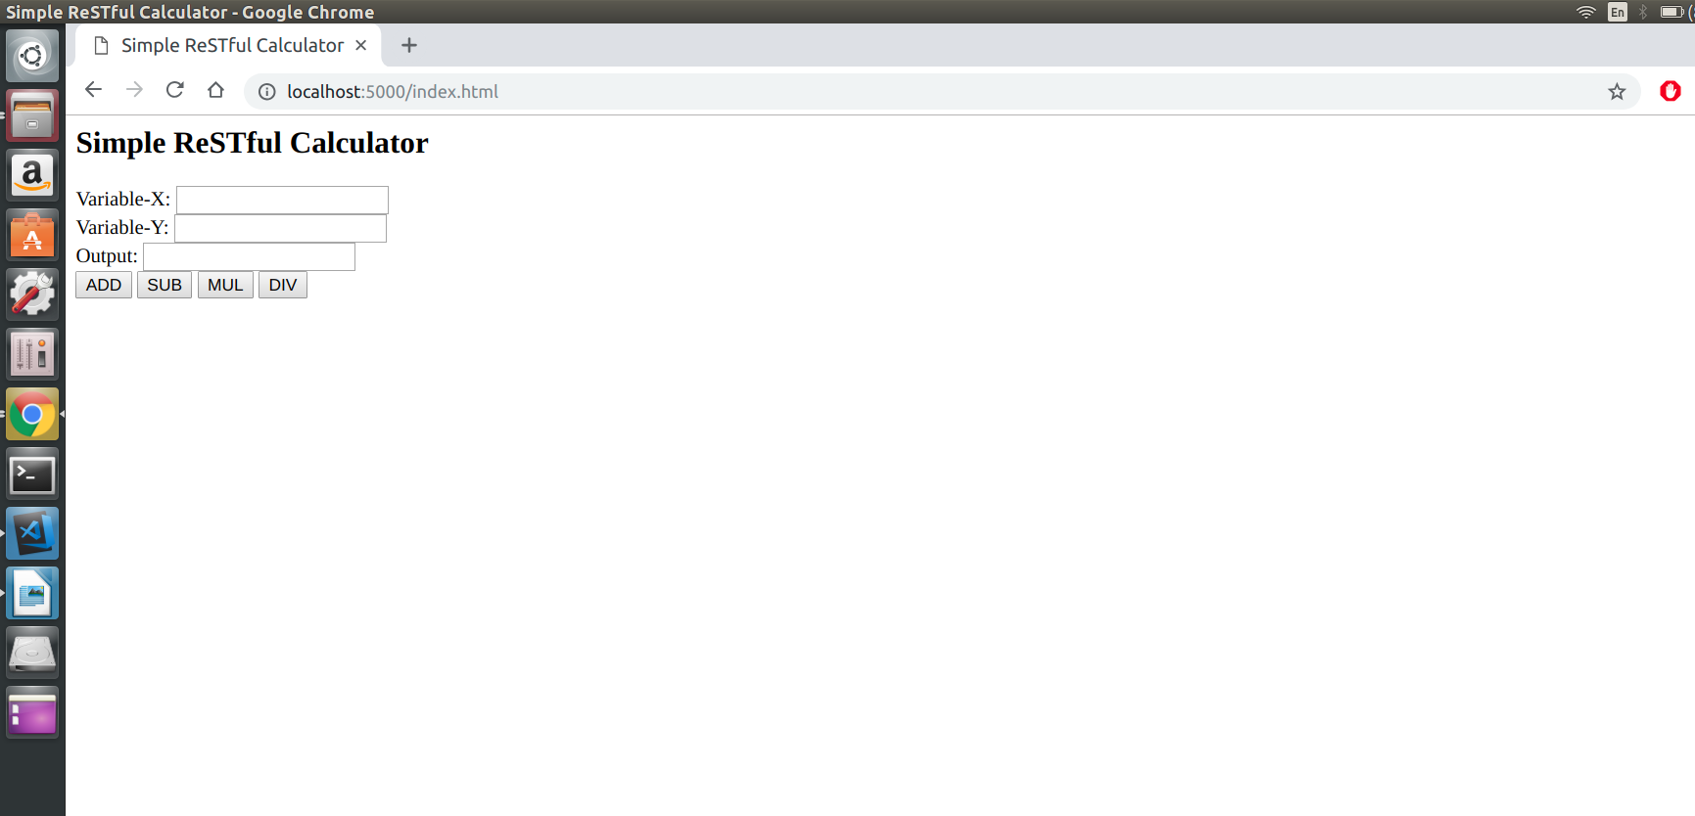
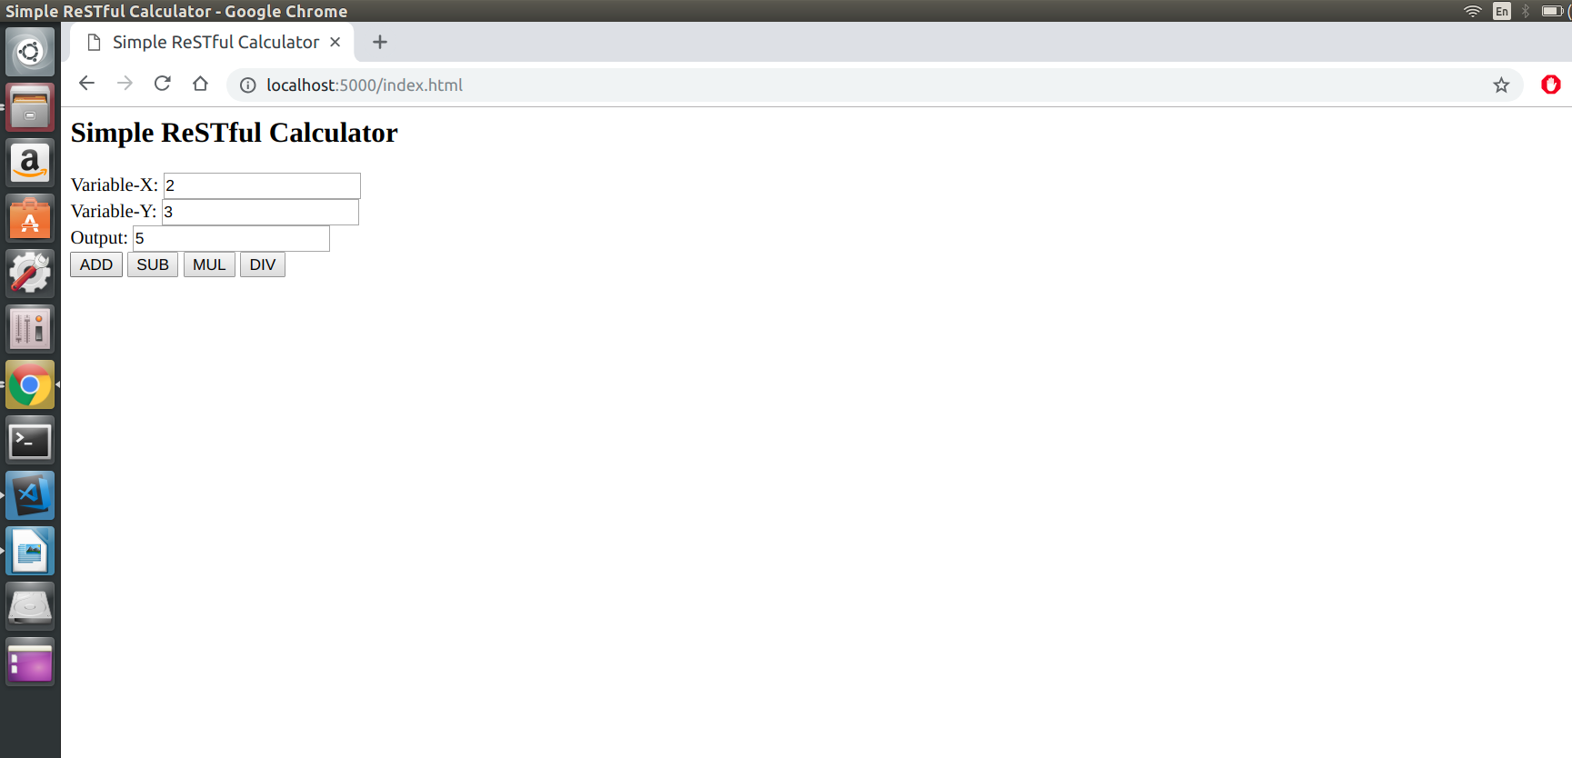
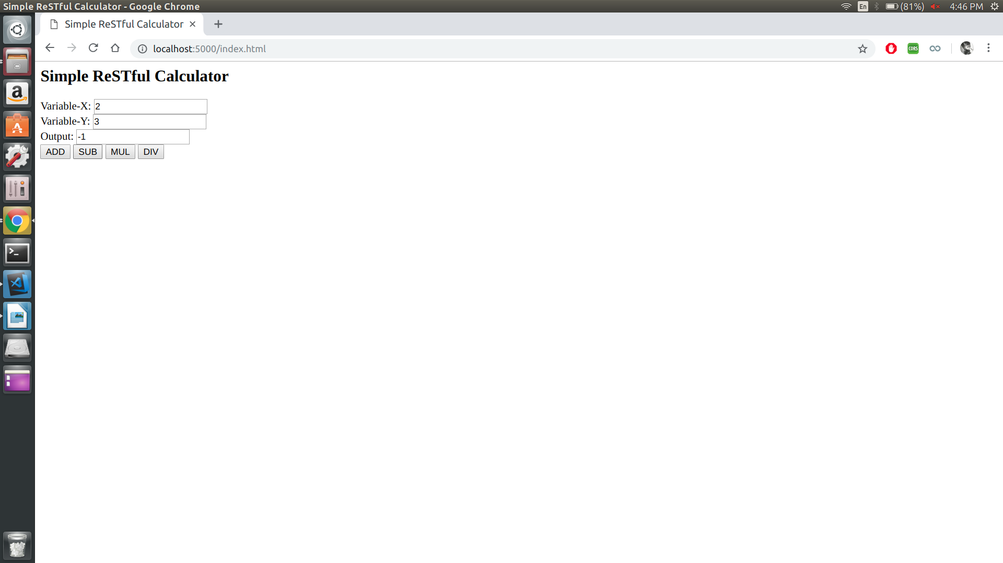
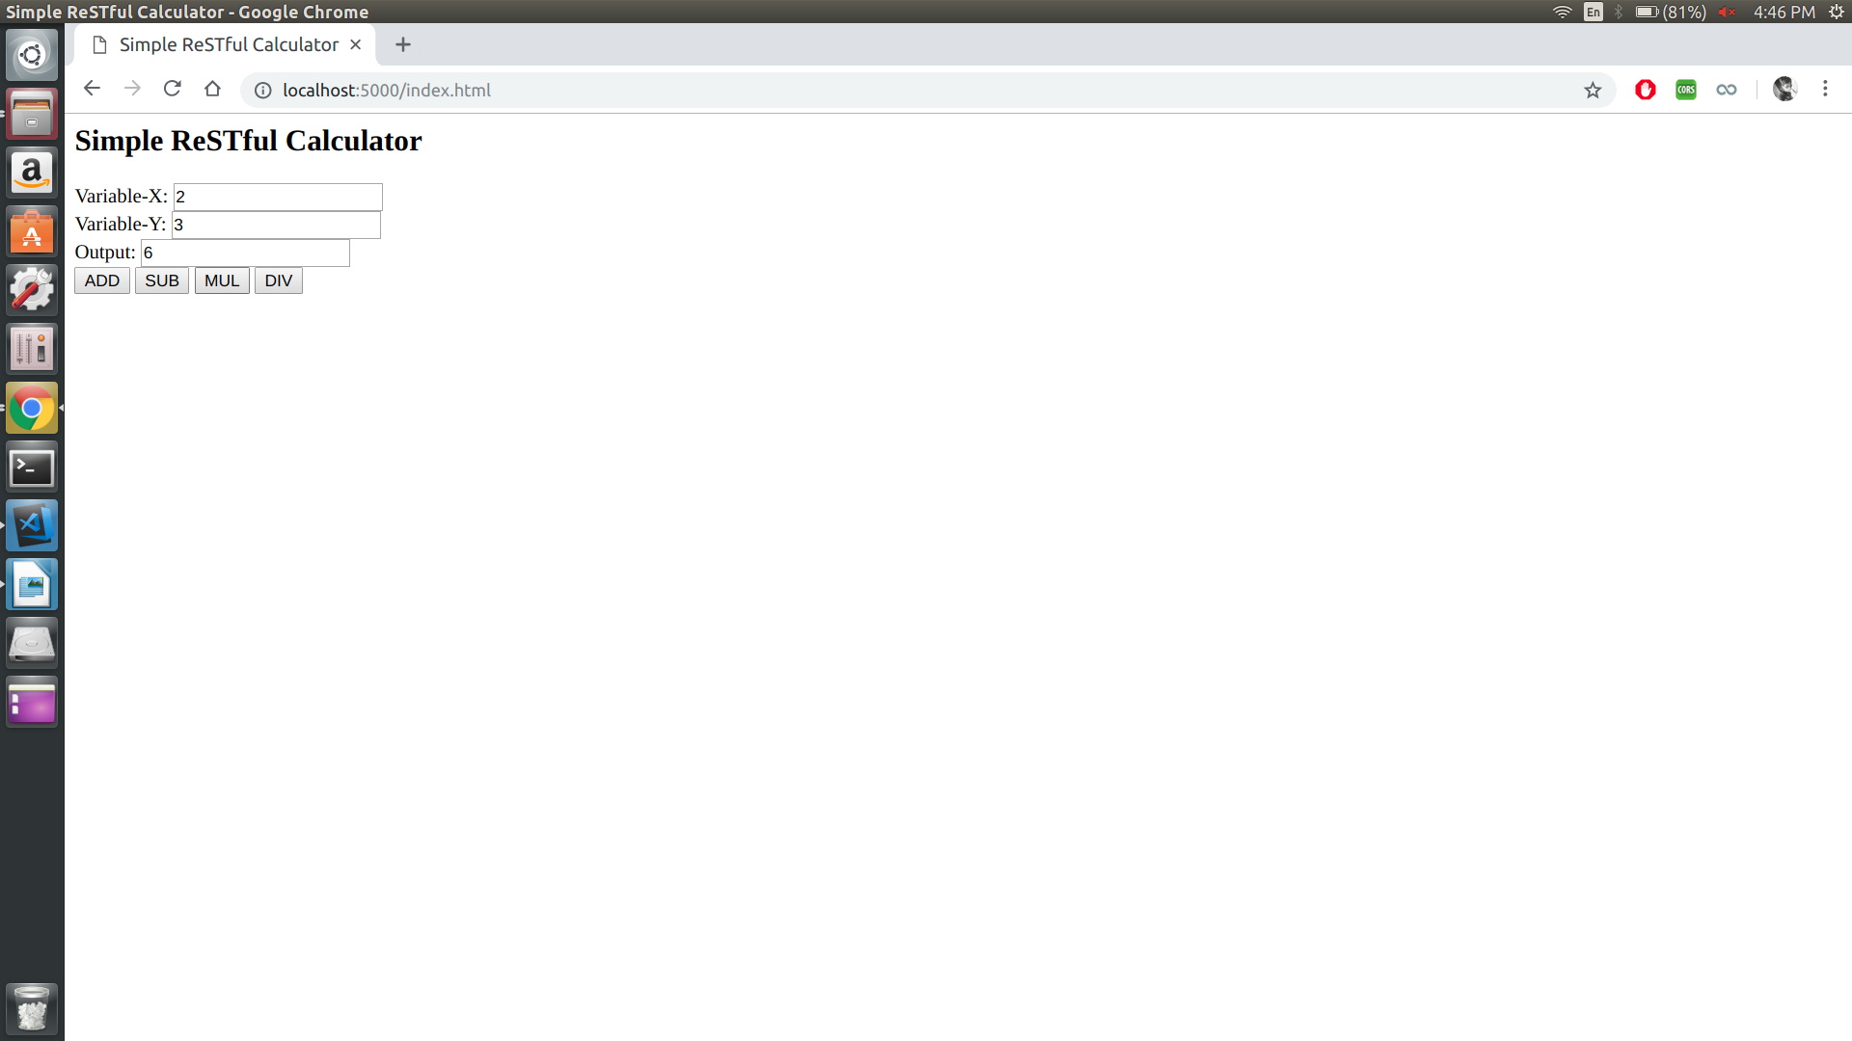
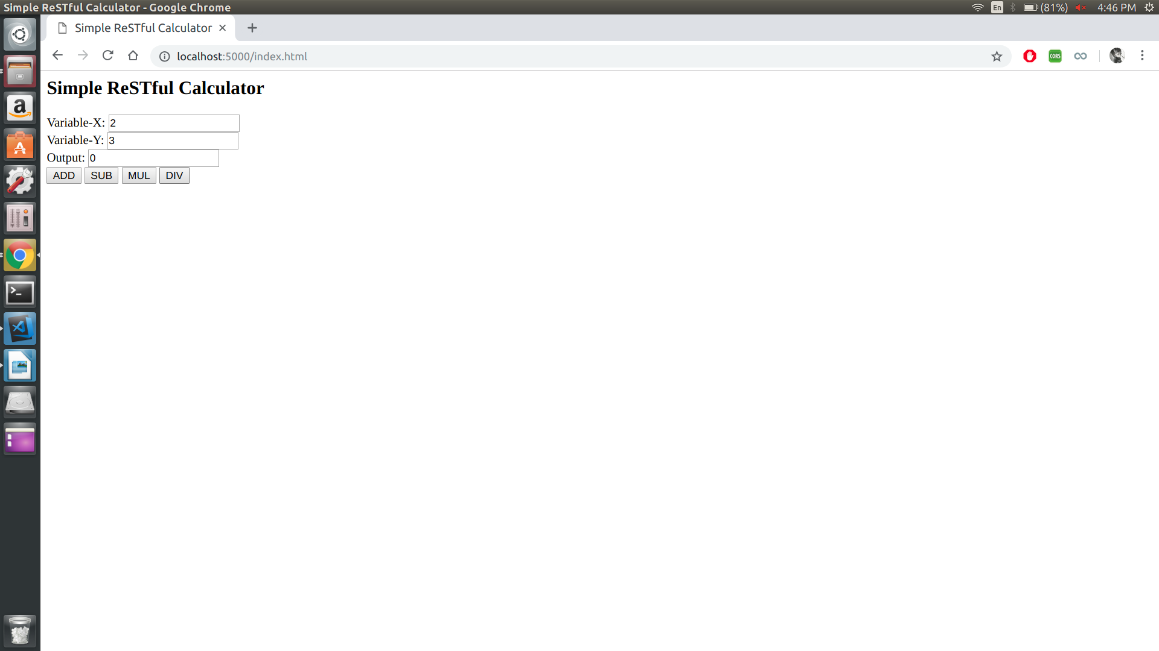

RESULT :
Thus the program is executed and output is obtained.

Program – 8

AIM :
To implement the following modules using Server Side Scripting (Python)
(i) Gathering form data.
(ii) Querying the database.
(iii) Response generation.
(iv) Session management.
(v) Use MySQL or JDBS or Oracle .

PROGRAM :

import mysql.connector
from flask import Flask, request

app = Flask(__name__,static_url_path = "")

@app.route('/result/<string:x>&<string:y>', methods = ['GET'])
def result(x,y):
try:
db = mysql.connector.connect(host="localhost",user="root",password="Sid_12345", database="test")
print(db)
cursor = db.cursor()

sql = "SELECT * from student where RegNo ='"+x+"' and Password='"+y+"';"
print(sql)

cursor.execute(sql)
result = cursor.fetchall()
print(result)
if len(result) == 0:
return "Please Verify Credentials"

ans = ""
for a in result:
for b in range(0,len(a)):
ans=ans+"#"+str(a[b])

return ans

except Exception as e:
print('Exception caught', e)

if __name__ == '__main__':
app.run(host='127.0.0.1',port=5555,debug = True)

OUTPUT :

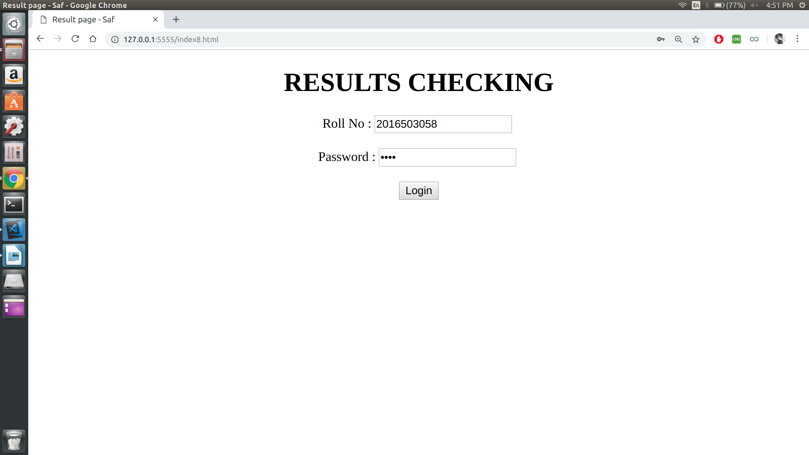
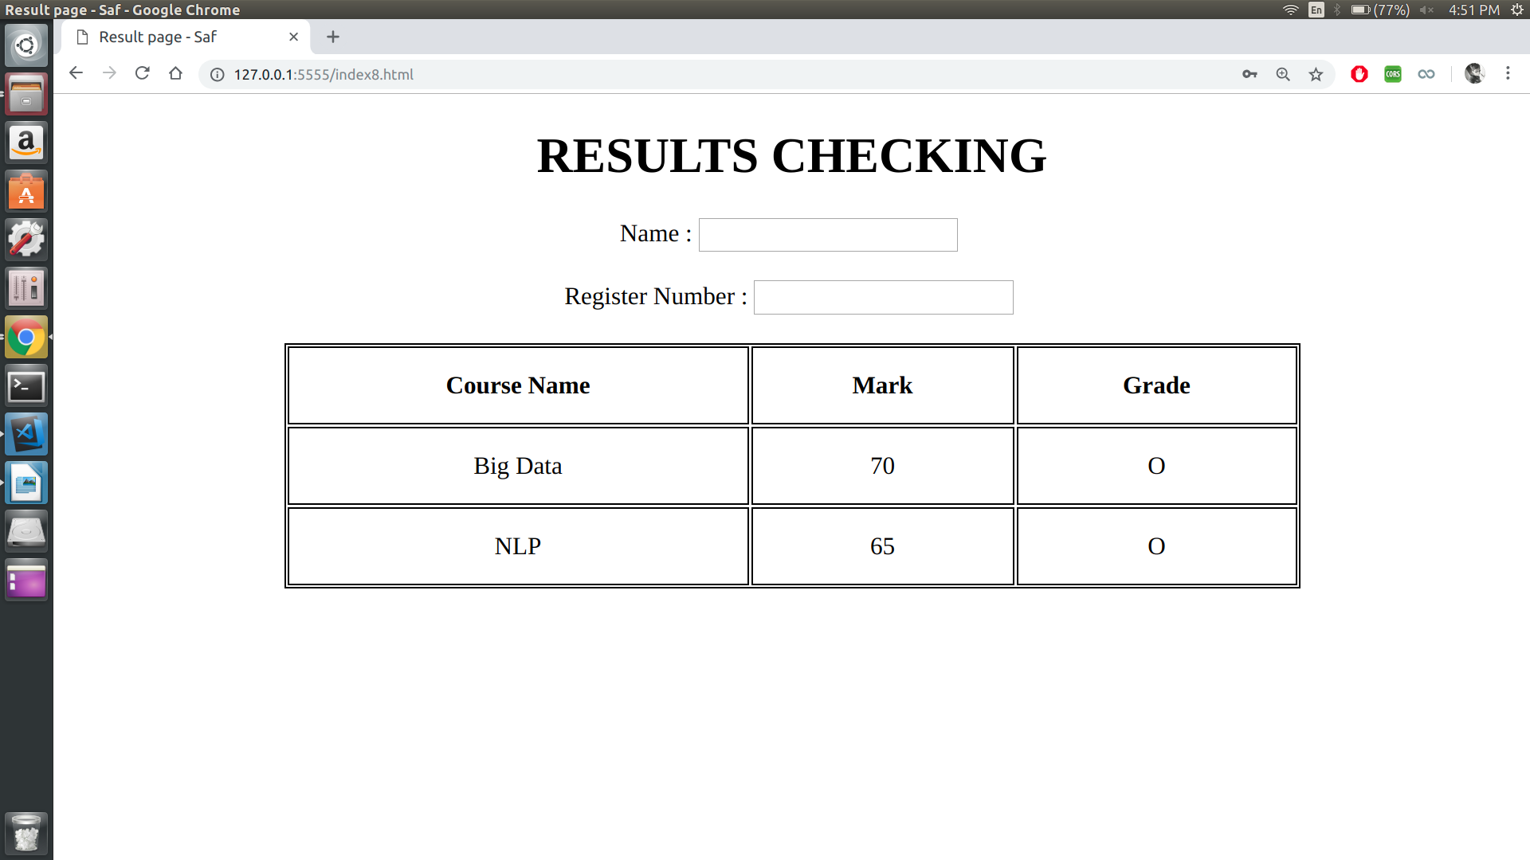

RESULT :
Thus the program is executed and output is obtained.

